**NITTE MEENAKSHI INSTITUTE OF TECHNOLOGY**

(AN AUTONOMOUS INSTITUTION)

(AFFILIATED TO VISVESVARAYA TECHNOLOGICAL UNIVERSITY, BELGAUM, APPROVED BY AICTE & GOVT.OF KARNATAKA)



**MINI-PROJECT**

**ON**

**“OBJECT DETECTIon USING ARDUINO”**

***SUBMITTED BY:***  **REG NO. USN**

MOHAN SAI KIRAN B 17692 1NT16CS056

MOHAMED JAFFAR NIYAZ 17946 1NT16CS157

*Submitted in partial fulfillment of the requirement for the award of Degree of BACHELOR OF ENGINEERING*

**Under the Guidance of HOD, Signature**

Dr. Thippeswamy MN

Department of Computer Science and Engineering

Nitte Meenakshi Institute of Technology,

Yelahanka, Bangalore– 560064

Academic Year 2017-2018

**NITTE MEENAKSHI INSTITUTE OF TECHNOLOGY**

(AN AUTONOMOUS INSTITUTION)

(AFFILIATED TO VISVESVARAYA TECHNOLOGICAL UNIVERSITY, BELGAUM, APPROVED BY AICTE & GOVT.OF KARNATAKA)



**CERTIFICATE**

**This is to certify that the Mini Project Report entitled**

**“OBJECT DETECTION uSING ARDUINO”**

is an authentic work carried out by,

***NAME :***  **REG NO. USN**

MOHAN SAI KIRAN B 17692 1NT16CS056

MOHAMED JAFFAR NIYAZ 17946 1NT16CS157

In partial fulfillment of the requirements for the completion of Mini Project for the academic year 2017-2018.

Name & Signature of the Guide Name & Signature of HOD

Name & Signature of the Examiner

**ACKNOWLEDGEMENT**

The satisfaction and euphoria that accompany the successful completion of any task would be incomplete without the mention of people who made it possible, whose constant guide and encouragement crowned our efforts with success.

We would like express our gratitude to our **Principal**, **Dr. H C NAGARAJ**.

We would also like to express our greatest thanks to our guide, **HOD, Dr. Thippeswamy** for giving us such a concept to work on and for his valuable effort, support and guidance without which this project would not have been possible.

We would like to thank our friends and parents for providing inspiration to successfully complete the project.

We would like to mention special thanks to the staff of **CSE Department, NMIT** for their support.

**ABSTRACT**

The Internet of Things (IoT) is a system of interrelated computing devices, mechanical and digital machines, objects, animals or people that are provided with [unique identifiers](http://whatis.techtarget.com/definition/unique-identifier-UID) and the ability to transfer data over a network without requiring human-to-human or human-to-computer interaction.

This project is an introduction or can be called as a prototype in IoT where we have made a set-up for an object detection using Arduino board at given particular ranges.

Our model consists of three LED’s, one buzzer, one ultrasonic and an LED . When the object gets closer to the model, depending upon the ranges specified, respective LED’s starts glowing. Once the object is very closer to the model, a particular LED as well as the buzzer sound starts. The LCD display is used to display the distance of the object from the model. Coding language used here is ‘C Programming’ and ‘Arduino language’.

Code consists of pin number’s specified for the equipment’s (like LED’s, buzzer, ultrasonic and an LED) and other functions for glowing of LED, buzzer sound and ‘if-else’ condition is used to specify the ranges for the ultrasonic.

It might be difficult for a new person to understand the code, but once he gets the hang of Arduino language, he will love to do more coding on it.

**TABLE OF CONTENTS**

|  |  |  |
| --- | --- | --- |
| **Chapter No.** | **Description** | **Page No.** |
| 1 | Introduction | 1 |
| 2 | System Analysis | 2 |
| 3 | Requirement Specifications | 3-4 |
| 4 | System Design | 5-6 |
| 5 | System Implementation | 7-9 |
| 6 | Result | 10-11 |
| 7 | Conclusion | 12 |
| 8 | References | 13 |

1. **INTRODUCTION**
   1. **Motivation**

Being a Computer Science student and the rapid evolution taking place in the field of Computer’s, it is required for a CSE student to gain equal knowledge in Hardware with respect to the Software.

Hence, this was an opportunity for us to do a project related to a combination of Hardware and Software, i.e. IoT (Internet of Things).

Like other programming languages or other data base managements like Python, Android, Hadoop, which boomed in the previous few years, IoT is the latest technology into which people are interested to work on and to gather knowledge.

Hence, we are glad that we got such a topic to work on and would be happy to do more work and projects into the field of IoT.

* 1. **Problem Statement**

The Object Detection in a real world has a great importance. This could help the physically challenged in the society. They face several difficulties with their inability to see objects and may lead to several disasters. But with the use of this Object detection technology, we can change the present situation and implement this technology with the help of wearable Object detection glasses or by using a Smart walking stick which use the same principle as of our project.

* 1. **Objective**

The main objective of this project is to detect the presence of an object.

This is done with a set of hardware components like the Arduino board, bread board, Jumpers, LED’s, Ultrasonic sensor and Buzzer.

A set of code is written into the software, which guides the board for the operations to be performed. When the object gets closer to the prototype, the LED’s starts glowing or the buzzer buzzes depending upon the condition specified in the code.

1. **SYSTEM ANALYSIS**
   1. **Existing System**

Using LED’s is the most basic thing in an Arduino. The LED’s are used as a standard output in any device. These help in the identification of the output. Usage of the Ultrasonic sensor and the Buzzer in the respective automotive fields. The Ultrasonic sensor has a trigger pin and an echo pin. It emits Ultrasonic radiation from the trigger pin and when strikes an object they reflect back and are detected by the echo pin. This is the existing working principle of the Ultrasonic sensor. The buzzer also acts as an indicator for the output. The sound intensity can be controlled using Arduino.

* 1. **Proposed System**

Usage of different color of LED’s and different ranges of distances for object detection.

The combination of all the components as mentioned in the existing system will give us the proposed system. The circuit is connected using all those components and the Arduino board is coded for the working of the project. This being our prototype project, a basic project for our understanding of IoT and its hardware components, we will try to include more new innovative ideas in the upcoming years and would like to help blind people through our project as object detection is a integral part for their local transportation.

1. **REQUIREMENT SPECIFICATIONS**
   1. **Software Requirements**
2. Operating System (OS): An Operating system is a system software that manages computer hardware and software resources and provides common services for computer programs .In our project we have used Windows 10. Recommended OS is Windows 8 and above.
3. Arduino software: A software which creates a connection or links between the Arduino Board and the code. In our project, we have used Arduino Software version 1.5.6. Software version 1.5.6 and above can also be used.
   1. **Hardware Requirement**
4. Arduino Board:

Arduino board consists of both physical-programmable circuit board or a microcontroller and software or referred as IDE (Integrated Development Environment) that runs on a computer, used to write and upload computer code to the physical board.

For our project, we have used Arduino Uno board, which is not wireless, requires wires/jumpers for the connections.

1. Bread Board:

It’s an electronic breadboard, referred to as solderless breadboard. These are great units for making temporary circuits and prototyping and requires no soldering.

Multiple equipment’s like the ultrasonic, buzzer, LED’s are put in the bread board, which then is connected to the Arduino board via ‘jumpers’.

1. LED’s:

Light Emitting Diode (LED) is a [semiconductor](http://searchcio-midmarket.techtarget.com/definition/semiconductor) device that emits visible light when an electric [current](http://searchcio-midmarket.techtarget.com/definition/current) passes through it.

We have used three LED’s in our set-up, where the light glows depending upon the range from the object.

1. Ultrasonic Sensor:

An Ultrasonic sensor is a device that can measure the distance to an object by using sound waves. It measures distance by sending out a sound wave at a specific frequency and listening for that sound wave to bounce back.

In our model, the ultrasonic sends signal to the Arduino, telling about the distance from the object and the respective operation will be performed depending upon the condition specified.

1. Buzzer:

A buzzer or beeper is an audio signaling device, which may be mechanical, electromechanical or piezoelectric. Typical uses of buzzers and beepers include alarm devices, timers, and confirmation of user input such as a mouse click or keystroke.

In our project, when an object gets extremely close to the model (close to <10cm), the buzzer starts.

1. Jumpers:

Jumpers consist of a set of small pins that can be covered with a small plastic box (jumper block). Jumpers are used to configure the settings for computer peripherals such as the motherboard, hard drives, modems, sound cards, and other components.

A couple of jumpers have been used for the connections and can be considered as the best use of wires for the bread board.

1. Nokia 5110 LCD:

The Nokia 5110 is a basic graphic LCD screen with lots of applications. It uses the PCD8544 controller, designed to give a graphic display of 48 rows and 84 columns. It is connected to the 3.3v supply at the Arduino board.

To interface with the LED and power it, There are 8 pins on the LCD display such as RST pin(Reset), CE pin(Chip Select), DC pin(Data Mode), DIN pin(Data In),CLK pin(Clock), VCC pin, BL pin(Back Light LED control), GND pin. For the functioning of this LCD in the Arduino board, we should include separate drivers or graphics controllers. We have used the U8glib library for the working of the Nokia 5110 LCD.

1. **SYSTEM DESIGN**
   1. **Circuit Diagram**

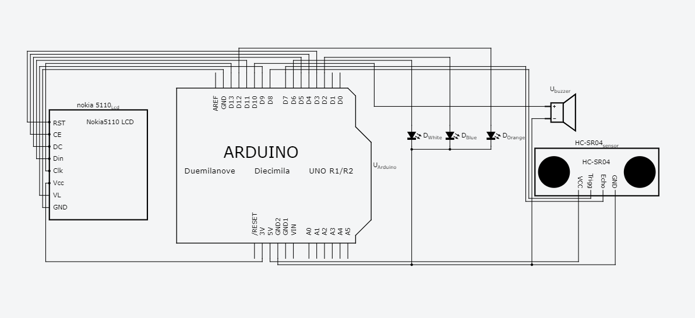

* 1. **Circuit Connections**

The connections are made as follows:

* The VCC of 5v and GND connections are made for the Ultrasonic sensor.
* The Trig Pin and Echo Pin of the Ultrasonic sensor are connected to pin 8 and pin 7 respectively.
* The –ve Terminal of buzzer is grounded and the +ve Terminal is connected to pin 10 of Arduino board.
* The 3 LED’s are grounded at the negative terminal and the +ve terminal are connected to pin 2 for blue color, pin 12 for orange color and pin 6 for white color.
* The connections in the LCD are made by connecting the VCC to 3.3v and the GND. The other connections are CLK to pin 13, DIN to pin 11, CE to pin 4, DC to pin 5, RST to pin 3, BL to pin 9 respectively.
* All these above mentioned connections are made using a Bread Board. For the connections to be made Jumper Wires are used and the above procedure is followed.
* A connection is made using the Usb of the Laptop and the Arduino board for uploading the code to the board and for It’s working.
  1. **Circuit Flow**

The Circuit Flow is as follows:

* High level signal is sent for 10us using Trigger of the Ultrasonic sensor.
* The Module sends eight 40 Khz signals automatically, and further detects if an object is detected or not.
* If signal is received then the echo pin is at high level.
* By using pulseIn function, the time duration is measured between sending and receiving the signal.
* The distance is calculated using duration and further by the conditions mentioned in the code, the LED’s and the Buzzer are triggered.
* The LCD display used in the model, based on the distance measured by the Ultrasonic sensor it displays the distance of the object from the model in Cm.

1. **System Implementation**

**Code**

/*Object detection using Arduino : We are detecting the object present using the ultrasonic sensor and displaying on the Lcd Screen*/

#include <U8glib.h>

#define backlight_pin 9

U8GLIB_PCD8544 u8g(13, 11, 4, 5, 3); // CLK=13, DIN=11, CE=4, DC=5, RST=3, BL=9

// Define pins for ultrasonic and buzzer

int const trigPin = 8;

int const echoPin = 7;

int const buzzPin = 10; //Buzzer

int const led1Pin = 6; //white

int const led2Pin = 12; //orange

int const led3Pin = 2; //blue

int sound=100;

int distance,duration;

void draw(void) {

u8g.setFont(u8g_font_profont11); // select font

u8g.drawStr(0, 10, "Distance (cm)"); // put string of display at position X, Y

u8g.setPrintPos(4,20); // set position for ditance measurement

u8g.print(distance); // display distance from ultrasonic sensor

}

void setup(void)

{

analogWrite(backlight_pin, 150);

pinMode(trigPin, OUTPUT);

pinMode(echoPin, INPUT);

pinMode(buzzPin, OUTPUT);

pinMode(led1Pin, OUTPUT);

pinMode(led2Pin, OUTPUT);

pinMode(led3Pin, OUTPUT);

Serial.begin(9600);

}

void loop(void)

{

digitalWrite(led1Pin,LOW);

digitalWrite(led2Pin,LOW);

digitalWrite(led3Pin,LOW);

noTone(buzzPin);

digitalWrite(trigPin, HIGH);

delay(1);

digitalWrite(trigPin, LOW);

duration = pulseIn(echoPin, HIGH);

distance = (duration/2) / 29.1;

u8g.firstPage();

do {

draw();

} while( u8g.nextPage() );

// For distance less than 15cm

if (distance <= 15 && distance >= 0)

{

digitalWrite(led3Pin,HIGH);

tone(buzzPin,sound);

Serial.println("Distance : ");

Serial.println(distance);

Serial.println(" cm");

}

// For distance less than 30

else if (distance <= 30 && distance >= 0)

{

digitalWrite(led2Pin,HIGH);

Serial.println("Distance : ");

Serial.println(distance);

Serial.println(" cm");

}

//For distance less than 60

else if (distance <= 60 && distance >= 0)

{

digitalWrite(led1Pin,HIGH);

Serial.println("Distance : ");

Serial.println(distance);

Serial.println(" cm");

}

else

{

Serial.println("Out of range ");

}

delay(800);

}

1. **Result**

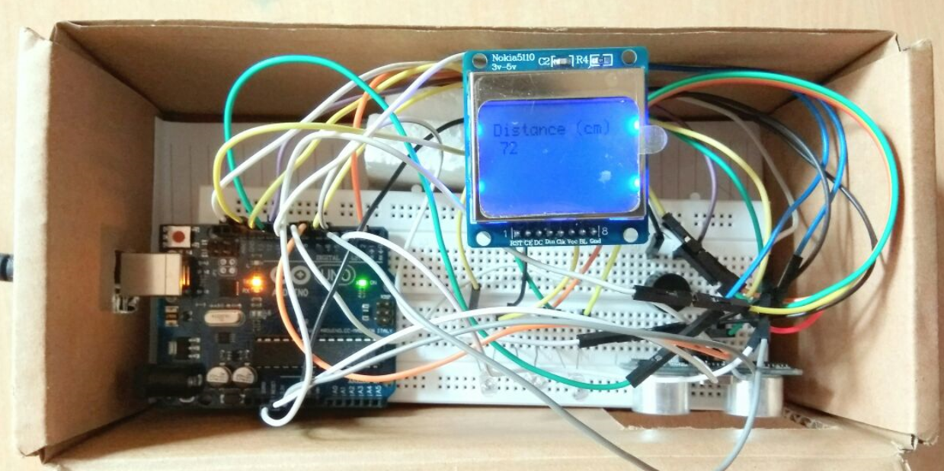

The above image indicates the distance as 72 cm, Based on the conditions mentioned no LED’s are lit up since the distance is greater than 60 cm.

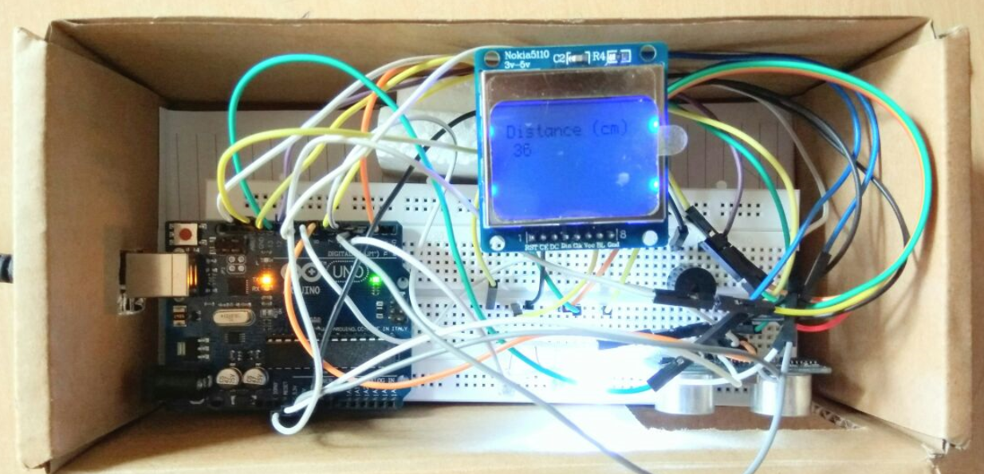

The above image indicates the distance as 36 cm, Thus the white color LED is lit indicating the first condition that is, The distance of the object is between 30 cm to 60 cm.

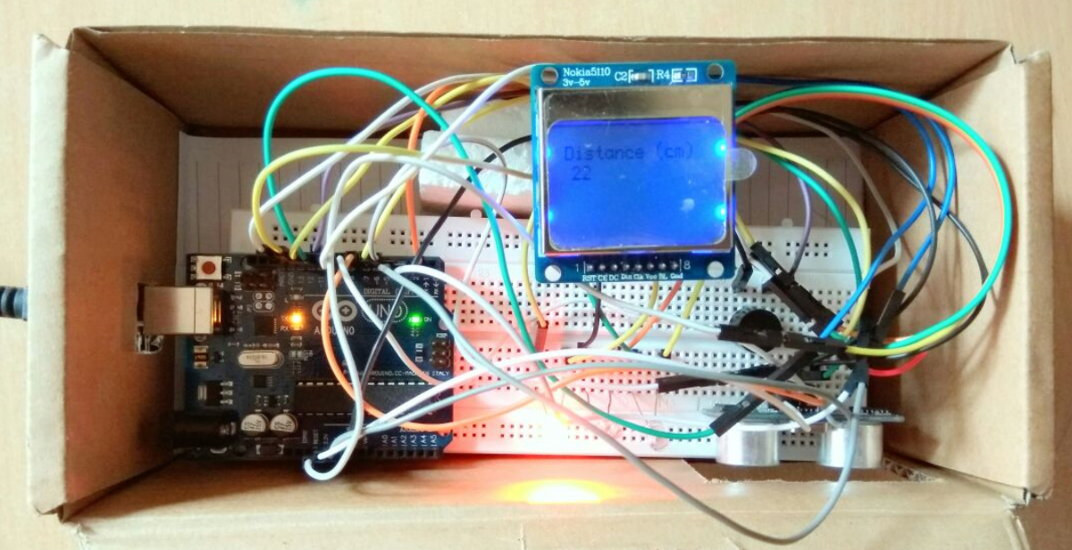

The above figure indicates the distance as 22 cm, because of which the orange LED is lit indicating the distance of the object in the range of 15 cm to 30 cm.

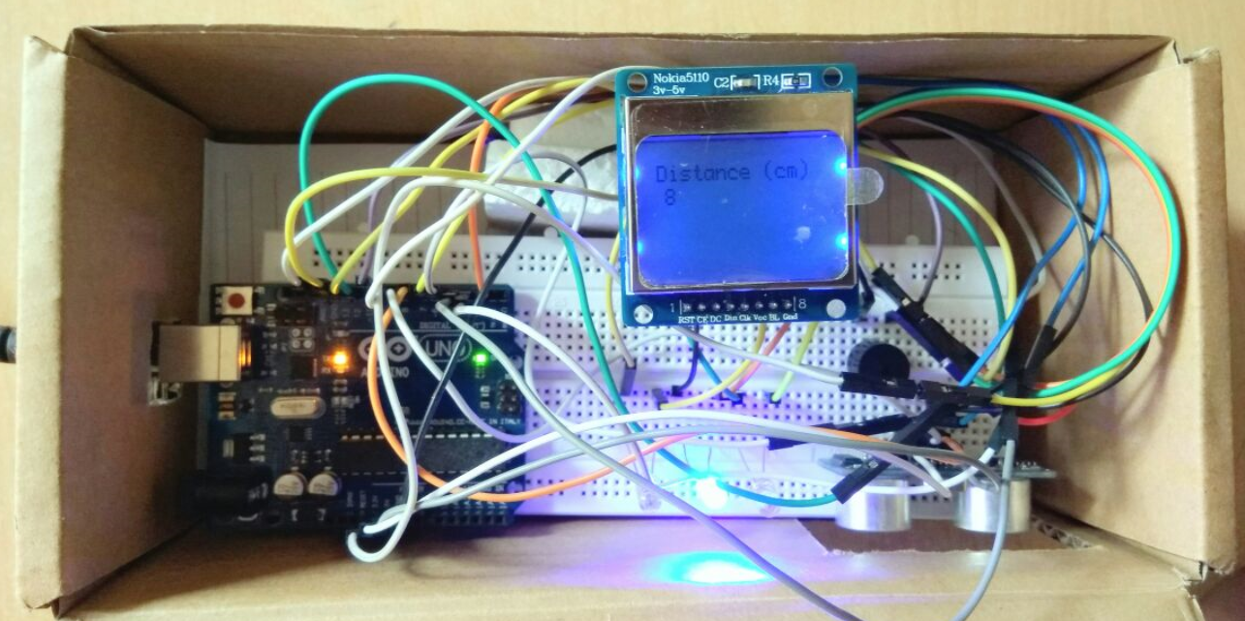

The above image indicates that the distance is 8 cm, because of which the blue LED is lit indicating the distance of the object in the range less than 15 cm.

1. **Conclusion**

From this project, we have learnt the importance IoT and its use in the everyday usage. IoT is a platform where we are giving life to most of our items (like the home appliances, street lights, watches, etc.) just by a term called as ‘NETWORK’. IoT is termed as the ‘Future-Technology’ where within few years of its development, billions of appliances will be connected to network and will make our life easier.

We have also, through this project understood the working of the above-mentioned concepts to a thorough extent and we will try to convert our prototype into a real-world functioning device with many new creative and innovative ideas, which will be a helping tool for most of the blind people.

**8. References**

1. CSE HOD, Dr. Thippeswamy
2. “Internet of Things – A Hands-on Approach” , by Arshdeep Bahga
3. YouTube channel – “Arduino Course for Absolute Beginners”
4. [www.instructables.com/id/DIY-navigation-device-for-blind-people-using-Ardui/](http://www.instructables.com/id/DIY-navigation-device-for-blind-people-using-Ardui/)